The Church of the Epiphany



*The Episcopal Church in Agoura, Oak Park, and Westlake Village*

**The Third Sunday in Lent**

**March 7, 2021 10:00 a.m.**

**The Celebration of the Holy Eucharist**

**Gathering and Preparation**

**Prelude** Fughetta super Dies sind die heilgen zehn Gebot, BWV 679  Johann Sebastian Bach (1685-1750)

*These are the holy ten commandments,  
which were given us by our Lord God,  
through Moses, his loyal servant,  
on top of Mount Sinai.  
Kyrie eleison.*  
  
Verse 1 of Catechesis Hymn text by Martin Luther (1483-1546)

**The Word of God**

*Priest* Blessed be the God of our salvation:

*People* **Who bears our burdens and forgives our sins.**

The Hymnal 1982 - #372 Praise to the living God

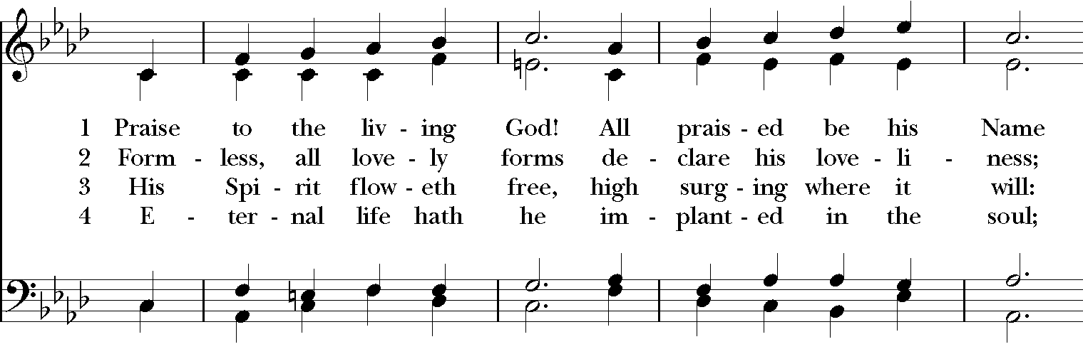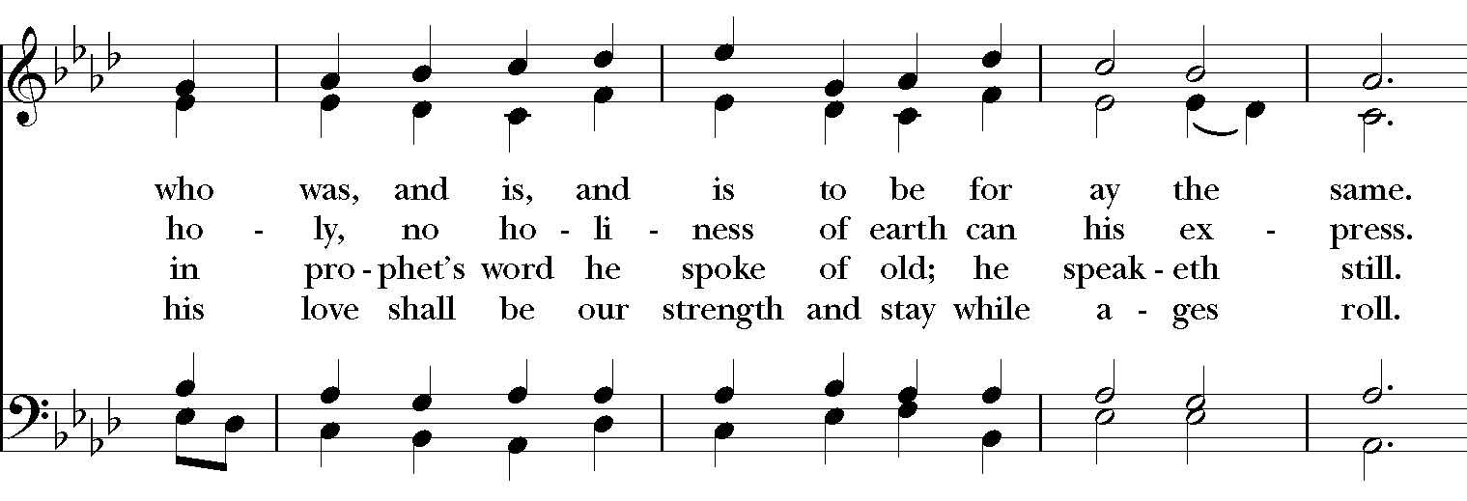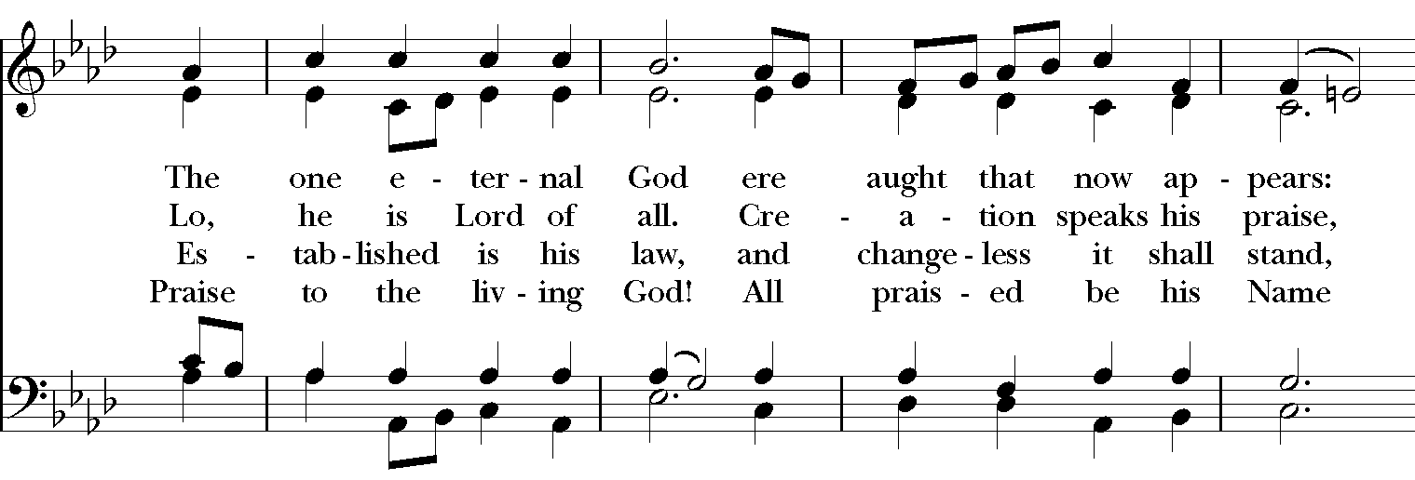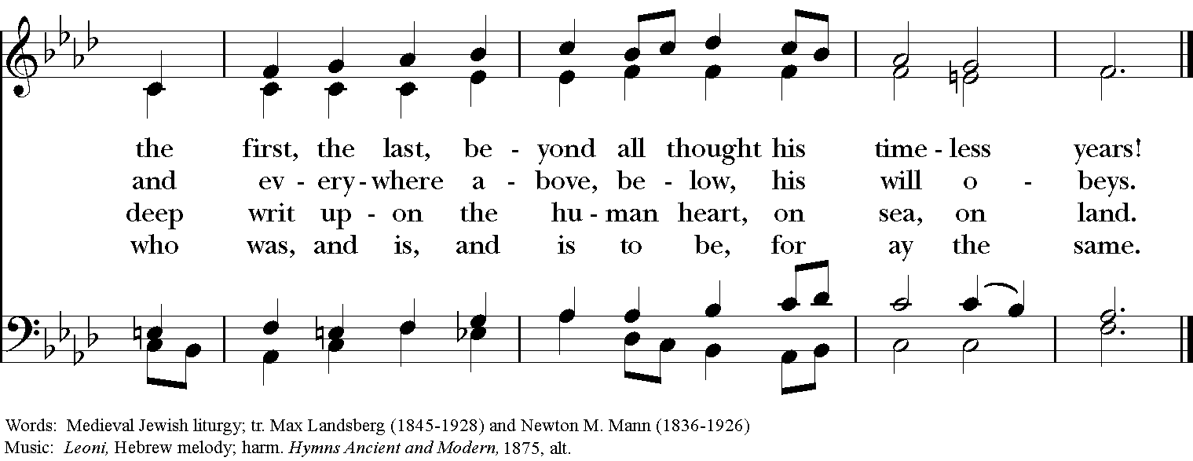

*Priest*  Compassion and forgiveness belong to the Lord our God. Let us renounce our willfulness and ask God’s mercy by recalling and confessing our sins in penitence and faith.

*Silence is kept.*

*Priest* God of all mercy,

*People* **We confess that we have sinned against you, opposing your will in our lives. We have denied your goodness in each other, in ourselves, and in the world you have created. We repent of the evil that enslaves us, the evil we have done, and the evil done on our behalf. Forgive, restore, and strengthen us through our Savior Jesus Christ, that we may abide in your love and serve only your will. Amen.**

*The priest concludes with an absolution.*

**Trisagion S-102** *sung three times, by all*Alexander Archangelsky (1846-1924)

*C:\Rite Song Exports\Thursday, February 19, 2015\S102a.TIF*

*The priest offers*

**The Collect for** **the Third Sunday in Lent**

*Priest* The Lord be with you.

*People*  **And also with you.**

*Priest* Let us pray.

*Silence is kept.*  *The Collect is said, after which the congregation responds:* **Amen***.*

Almighty God, you know that we have no power in ourselves to help ourselves: Keep us both outwardly in our bodies and inwardly in our souls, that we may be defended from all adversities which may happen to the body, and from all evil thoughts which may assault and hurt the soul; through Jesus Christ our Lord, who lives and reigns with you and the Holy Spirit, one God, for ever and ever.*Amen*

**First Reading Exodus 20:1-17**

Then God spoke all these words:

I am the Lord your God, who brought you out of the land of Egypt, out of the house of slavery; you shall have no other gods before me.

You shall not make for yourself an idol, whether in the form of anything that is in heaven above, or that is on the earth beneath, or that is in the water under the earth. You shall not bow down to them or worship them; for I the Lord your God am a jealous God, punishing children for the iniquity of parents, to the third and the fourth generation of those who reject me, but showing steadfast love to the thousandth generation of those who love me and keep my commandments.

You shall not make wrongful use of the name of the Lord your God, for the Lord will not acquit anyone who misuses his name.

Remember the sabbath day, and keep it holy. For six days you shall labour and do all your work. But the seventh day is a sabbath to the Lord your God; you shall not do any work—you, your son or your daughter, your male or female slave, your livestock, or the alien resident in your towns. For in six days the Lord made heaven and earth, the sea, and all that is in them, but rested the seventh day; therefore the Lord blessed the sabbath day and consecrated it.

Honor your father and your mother, so that your days may be long in the land that the Lord your God is giving you.

You shall not murder.

You shall not commit adultery.

You shall not steal.

You shall not bear false witness against your neighbor.

You shall not covet your neighbor’s house; you shall not covet your neighbor’s wife, or male or female slave, or ox, or donkey, or anything that belongs to your neighbor.

*Response after the reading:***Thanks be to God.**

*The people say together*

**Psalm 19**

***Caeli enarrant***

1 The heavens declare the glory of God, *  
and the firmament shows his handiwork.

2 One day tells its tale to another, *  
and one night imparts knowledge to another.

3 Although they have no words or language, *  
and their voices are not heard,

4 Their sound has gone out into all lands, *  
and their message to the ends of the world.

5 In the deep has he set a pavilion for the sun; *  
it comes forth like a bridegroom out of his chamber;  
it rejoices like a champion to run its course.

6 It goes forth from the uttermost edge of the heavens  
and runs about to the end of it again; *  
nothing is hidden from its burning heat.

7 The law of the Lord is perfect  
and revives the soul; *  
the testimony of the Lord is sure  
and gives wisdom to the innocent.

8 The statutes of the Lord are just  
and rejoice the heart; *  
the commandment of the Lord is clear  
and gives light to the eyes.

9 The fear of the Lord is clean  
and endures for ever; *  
the judgments of the Lord are true  
and righteous altogether.

10 More to be desired are they than gold,  
more than much fine gold, *  
sweeter far than honey,  
than honey in the comb.

11 By them also is your servant enlightened, *  
and in keeping them there is great reward.

12 Who can tell how often he offends? *  
cleanse me from my secret faults.

13 Above all, keep your servant from presumptuous sins;  
let them not get dominion over me; *  
then shall I be whole and sound,  
and innocent of a great offense.

14 Let the words of my mouth and the meditation of my  
heart be acceptable in your sight, *  
O Lord, my strength and my redeemer.

**Second Reading 1 Corinthians 1:18-25**

The message about the cross is foolishness to those who are perishing, but to us who are being saved it is the power of God. For it is written,

“I will destroy the wisdom of the wise,  
and the discernment of the discerning I will thwart.”

Where is the one who is wise? Where is the scribe? Where is the debater of this age? Has not God made foolish the wisdom of the world? For since, in the wisdom of God, the world did not know God through wisdom, God decided, through the foolishness of our proclamation, to save those who believe. For Jews demand signs and Greeks desire wisdom, but we proclaim Christ crucified, a stumbling block to Jews and foolishness to Gentiles, but to those who are the called, both Jews and Greeks, Christ the power of God and the wisdom of God. For God’s foolishness is wiser than human wisdom, and God’s weakness is stronger than human strength.

*Response after the reading:* **Thanks be to God.**

The Hymnal 1982 - #431 The stars declare his glory

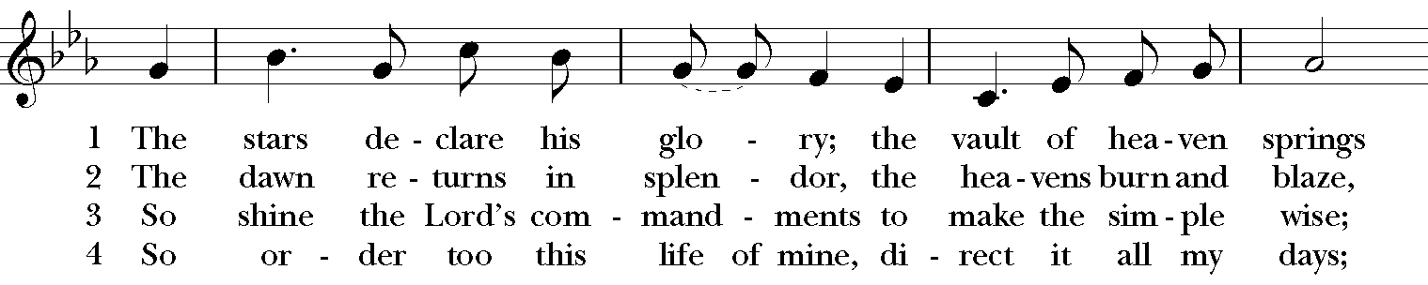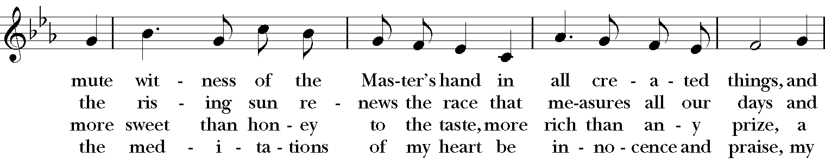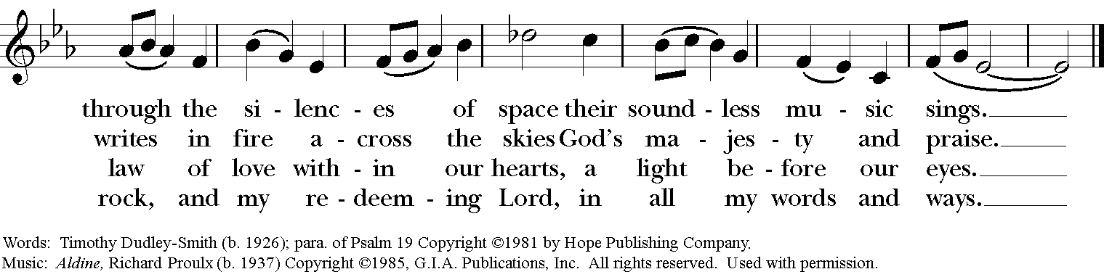

 **The Holy Gospel** **John 2:13-22**

*Response before the reading:* **Glory to you, Lord Christ.**

The Passover of the Jews was near, and Jesus went up to Jerusalem. In the temple he found people selling cattle, sheep, and doves, and the money changers seated at their tables. Making a whip of cords, he drove all of them out of the temple, both the sheep and the cattle. He also poured out the coins of the money changers and overturned their tables. He told those who were selling the doves, “Take these things out of here! Stop making my Father’s house a marketplace!” His disciples remembered that it was written, “Zeal for your house will consume me.” The Jews then said to him, “What sign can you show us for doing this?” Jesus answered them, “Destroy this temple, and in three days I will raise it up.” The Jews then said, “This temple has been under construction for forty-six years, and will you raise it up in three days?” But he was speaking of the temple of his body. After he was raised from the dead, his disciples remembered that he had said this; and they believed the scripture and the word that Jesus had spoken.

*Response after the reading:* **Praise to you, Lord Christ.**

**The Homily** The Very Rev. Dr. Canon Gary Hall

*We observe a time of silence after the homily.*

**The Nicene Creed**

**We believe in one God, the Father, the Almighty, maker of heaven and earth, of all that is, seen and unseen.**

**We believe in one Lord, Jesus Christ, the only Son of God, eternally begotten of the Father, God from God, Light from Light, true God from true God, begotten, not made, of one Being with the Father. Through him all things were made. For us and for our salvation he came down from heaven: by the power of the Holy Spirit he became incarnate from the Virgin Mary, and was made man. For our sake he was crucified under Pontius Pilate; he suffered death and was buried. On the third day he rose again in accordance with the Scriptures; he ascended into heaven and is seated at the right hand of the Father. He will come again in glory to judge the living and the dead, and his kingdom will have no end.**

**We believe in the Holy Spirit, the Lord, the giver of life, who proceeds from the Father and the Son. With the Father and the Son he is worshiped and glorified. He has spoken through the Prophets. We believe in one holy catholic and apostolic Church. We acknowledge one baptism for the forgiveness of sin. We look for the resurrection of the dead, and the life of the world to come. Amen.**

**The Prayers of Intercession**

*We observe a time of silence between each petition, offering our own intercessions,*

*until the leader says, “Lord in your mercy.”*

*People* **Hear our prayer***.*

*The leader adds a concluding sentence, after which all respond:* **Amen.**

For true holiness in the Church and in the world, let us pray to the Lord.

Shield the Church from all that would corrupt her witness and make her unworthy of her Master…May her places of worship be holy and her ministry unblemished by desire for material gain and worldly success.

Have mercy on the world where profit too often stands before people and the love of money is a stronger motive than the love of holiness…Drive out the false values by which some grow rich and many are poor, until the whole earth becomes a temple fit for the Lord.

Bless us, our families and friends, with such reverence in our faith that we may value the holiness that is in other people…Grant to those who conduct their business in this community the spirit of fair dealing and mutual respect.

Have mercy on all who have suffered loss from the dishonesty of those they trusted…Release from evil those who have made material profit their goal and have lost the peace of contentment.

We pray for the departed who having worshipped in this world have died with Christ and been raised up with him…May they rejoice in the heavenly Temple where he is the eternal light.

We pray in the name of Christ who drives out all that is evil.

**The Peace**

*Priest* The peace of Christ be always with you.

*People* **And also with you.**

*All may greet one another in the name of the Lord.*

**Prayer for Birthdays**

*All* **Watch over your *children*, O Lord, as *their* days increase; bless and guide *them* wherever they may be. Strengthen *them* when *they* stand; comfort *them* when discouraged or sorrowful; raise *them* up if *they* fall; and in *their* hearts may your peace which passes understanding abide all the days of *their* lives; through Jesus Christ our Lord. Amen.**

**The Holy Communion**

**Offertory** Day by day

Day by day, dear Lord, of thee three things I pray:  
 to see thee more clearly,  
 love thee more dearly,  
 follow thee more nearly,  
 day by day.

text: St. Richard of Chichester (1197-1253)

music: Martin How (b. 1931)

**The Great Thanksgiving**

*Priest* The Lord be with you.

*People* **And also with you.**

*Priest* Lift up your hearts.

*People* **We lift them to the Lord.**

*Priest* Let us give thanks to the Lord our God.

*People* **It is right to give God thanks and praise.**

*The priest continues with the prayer.*

**Sanctus S-129** Robert Powell (b. 1932)



*The priest continues with the prayer.*

*Priest* Therefore we proclaim the mystery of faith:

*People* **Christ has died,**

**Christ is risen,**

**Christ will come again.**

**The Lord’s Prayer**

*Priest* Now as our Savior Christ has taught us, we pray together.

*People* **Our Father, who art in heaven, hallowed be thy Name,**

**thy kingdom come, thy will be done, on earth as it is in heaven.**

**Give us this day our daily bread.**

**And forgive us our trespasses, as we forgive those who trespass against us.**

**And lead us not into temptation, but deliver us from evil.**

**For thine is the kingdom, and the power, and the glory, for ever and ever. Amen.**

**Spiritual Communion**

*In this time of social distancing, when we long for the physical Sacrament of Holy Communion but cannot - for safety - partake of it, it can be meaningful to pray for God's presence in our lives,  express our desire for Communion, and name our hope of taking part in the Sacrament soon.*

*Priest*      If you desire to receive the Eucharist, I invite you to pray with me this prayer of Spiritual Communion.

*People*      **Jesus, my savior and friend, I believe that you are truly present in the Sacrament of Holy Communion and truly present to us here and now. Since I cannot now receive you in the bread and wine, I remember and trust your words, “This is my body; this is my blood – given for you.” I love you and ask you to come spiritually into my heart. As though you have already come, I embrace you and unite myself entirely to you. Keep all of us strong in faith, hope, and love until we can meet at your table again. Amen.**

The Hymnal 1982 - #436 Lift up your heads, ye mighty gates

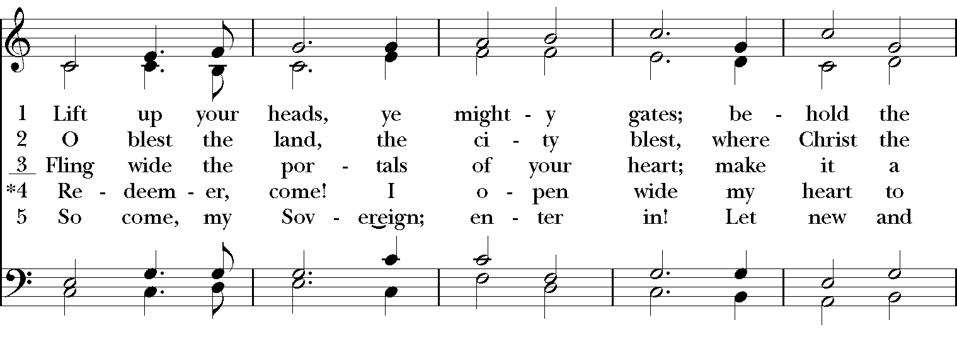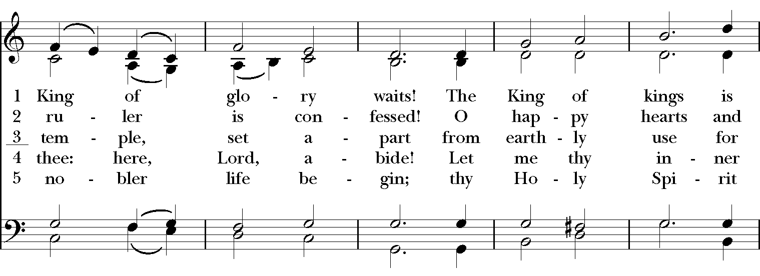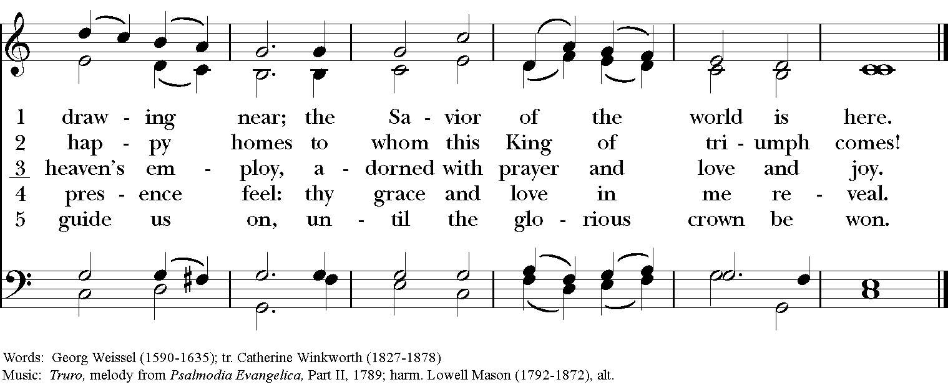

**SOLEMN PRAYER OVER THE PEOPLE**

Look mercifully on this your family, Almighty God, that by your great goodness they may be governed and preserved evermore; through Christ our Lord. *Amen.*

**The Dismissal**

*Priest:* Let us go forth in the name of Christ.

*People:* **Thanks be to God.**

“Holy God” (Trisagion) © 1985, The Church Pension Fund/Church Publishing.  Reproduced under OneLicense.net License No. A-717483.  All rights reserved.  
  
“Holy, holy, holy Lord” (Sanctus) by Robert Powell, © 1985, The Church Pension Fund/Church Publishing.  Reproduced under OneLicense.net License No. A-717483.  All rights reserved.

March 7***

Epiphany Connections

Connect with us! Visit us at [tcote.org](http://www.tcote.org) or send us an email at [info@tcote.org](mailto:info@tcote.org) to receive the latest news.

|  |  |  |  |
| --- | --- | --- | --- |
| tHIS WEEK:  **Today** Sunday Worship Service, 10:00 a.m. (Virtual)  **Tue.** Consolation in Community, 7:00-8:30 p.m.  **Wed.** Bible Study, 12 p.m.  Way of Love Series, 7 p.m.  **Sun.** Sunday Worship Service, 10 a.m. (Virtual)  **CONSOLATION IN COMMUNITY**  Beginning in March: The Church of the Epiphany, facilitated by Laurie Burns, is offering a weekly series of reflecting on, and processing the events that have transpired over the past four years-and most recently-in this last year when Covid kept us from gathering together in our beloved church. With our Vicar’s departure from Epiphany, we find ourselves with new challenges and new opportunities for growth and expansiveness as faithful disciples of Christ.  The question of “why” remains unanswered, but the feelings in response to what has happened to us as a community run deep. Coming together to hold each other up in support and love has never been more essential.  Please join us each Tuesday evening from **March 2nd to March 16 from 7:00-8:30 p.m.** Join [Zoom Meeting](Join%20Zoom%20Meeting%20https:/us02web.zoom.us/j/89997990166?pwd=RGlRVDhDQi8rN3RpYmdiaU1iNyswdz09)  **BIRTHDAYS AND ANNIVERSARIES**  **\*Please note the change in day for deadline\*** In order to have an accurate list of names during the prayers for birthdays and anniversaries, we are now asking all prayer requests to be submitted no later than **Wednesday night**. All submissions will be announced during that weekend’s service. Please email us the name or names, birthday (month & day) or anniversary date or you can complete the prayer request form on our website. If you prefer, you can call the office (818) 991-4797 with the information.  COVID-19 VACCINATIONS   |  | | --- | | **COVID-19 VACCINE INFORMATION** | | Below are links to the Ventura and Los Angeles County COVID-19 websites, where you can schedule appointments and find more information about the vaccine.  [Ventura County](https://www.venturacountyrecovers.org/vaccine-information/portal/)  [Los Angeles County](http://www.publichealth.lacounty.gov/media/Coronavirus/vaccine/index.htm) | | Announcements  *Love is the Way*: Five Week Lenten Series  **Wednesdays, March 10, 17, 24 at 7:00 pm**  Join Louise+ and Laurel+ for this Lenten Series based on Presiding Bishop Michael Curry’s newest book, Love Is the Way. In Love Is the Way Bishop Curry offers an inspirational road map for living the way of love through the prism of his faith, ancestry, and personal journey. In the words of reviewer Jon Meacham, “Michael Curry draws on his own remarkable life to show us the way we might make our own lives, and the lives of all nations, warmer, better and nobler.”  We will gather via Zoom on Wednesday evenings from 7:00 – 8:00 pm to view pre-recorded video reflections and engage in lively discussion..  Love is the Way Lenten Series  ([CLICK HERE FOR LINK TO LENTEN SERIES)](https://us02web.zoom.us/j/630075828?pwd=S05uWUJTeTZWS0NSV2VvU2pQUGNFZz09)  **Date Video Reflection**  Wed. March 10 The Very. Rev. Dr. Canon Gary Hall Interim Dean, Bloy House  Wed. March 17 Gabriel Vasquez- Reyes  Missioner for Youth  Wed. March 24 The Rt. Rev John H. Taylor, Bishop of Los Angeles  To view the videos and resources go [One in the Spirit](http://r20.rs6.net/tn.jsp?f=001MPgMQwlLsHc-X85zNwqqsOVfsz8yEqWSdFiSVTWV0RbDgVmqeVCLoYcd1Hx_EbQGA0i4rSqRA46RxJylLsmwKAZX4Ua1n95H72jKiehq3FKIyM1XE03EL9zM5ln4Gj3SUpfVM9oFM5_TEHcQ_ajx67etHdfIFtDI_s9Y9tAcf6w%3D&c=xYUqSE_ZX2QRjXhLKVZRFi1jQgYiR1nOjT4UhCKF-82CGBsvbmBubQ%3D%3D&ch=yNdvcXNbUDSCzVY2yenwRJo6ahOoPpX-_-IPGPJ8sIAlcHH5az7MNA%3D%3D) [webpage.](http://r20.rs6.net/tn.jsp?f=001MPgMQwlLsHc-X85zNwqqsOVfsz8yEqWSdFiSVTWV0RbDgVmqeVCLoYcd1Hx_EbQGA0i4rSqRA46RxJylLsmwKAZX4Ua1n95H72jKiehq3FKIyM1XE03EL9zM5ln4Gj3SUpfVM9oFM5_TEHcQ_ajx67etHdfIFtDI_s9Y9tAcf6w%3D&c=xYUqSE_ZX2QRjXhLKVZRFi1jQgYiR1nOjT4UhCKF-82CGBsvbmBubQ%3D%3D&ch=yNdvcXNbUDSCzVY2yenwRJo6ahOoPpX-_-IPGPJ8sIAlcHH5az7MNA%3D%3D) |

REFLECTION

"Our pre-recorded “tapes” in our subconscious (“How can this happen to me?” “How dare they/she/he ?” “They must do what I want.” "I am such a dufus.") are erased by repeating at moments of ease an active prayer sentence of six to twelve syllables, often a short passage of Scripture" - Thomas Keating